**SM2R2 Consulting**



**Da Vinci’s Pizza – Provisioning Data and Workload Analysis**

Susiette, Marco, Michael, Ron, Ray, Savitha

Contents

[Introduction 3](#_Toc3276754)

[Data Platform 3](#_Toc3276755)

[Additional Datasets 4](#_Toc3276756)

[City of Toronto Building Permits 4](#_Toc3276757)

[Pizza restaurants and the pizzas they sell – Kaggle 4](#_Toc3276758)

[Yelp Restaurant Review 5](#_Toc3276759)

[Twitter Reviews - Online Food Ordering Services 5](#_Toc3276760)

[Air Miles Canada Loyalty data 6](#_Toc3276761)

[Toronto - 2016\_neighbourhood\_profiles – Statistics Canada 7](#_Toc3276762)

[Data set analysis 8](#_Toc3276763)

[Strategic Workloads 9](#_Toc3276764)

[Efficient Life Cycle of Food and Beverage Ingredients 10](#_Toc3276765)

[Franchising the business 12](#_Toc3276766)

[Identify new locations 14](#_Toc3276767)

[Tactical Workloads 15](#_Toc3276768)

[Create a pizza community 16](#_Toc3276769)

[AIR MILES Rewards Program 17](#_Toc3276770)

[The AIR MILES Reward Program: Redemption, Earn Rate & Partners (Estimation) 18](#_Toc3276771)

[Operational Workloads 20](#_Toc3276772)

[Internal KPI 21](#_Toc3276773)

[Online/mobile App Ordering and Delivery System 22](#_Toc3276774)

[Summary 26](#_Toc3276775)

[Peer Review 26](#_Toc3276776)

# Introduction

Davinci’s Pizza is in an evolutionary phase in its growth cycle as they expand to use raw data as a key resource to make quantitative, fact based, insightful data driven decisions. There is a wide variety of data available from internal sources, as well as, external data.

# Data Platform

Microsoft Azure will be the data platform used to capture and manage a diverse set of data and transform into meaningful data and reports.

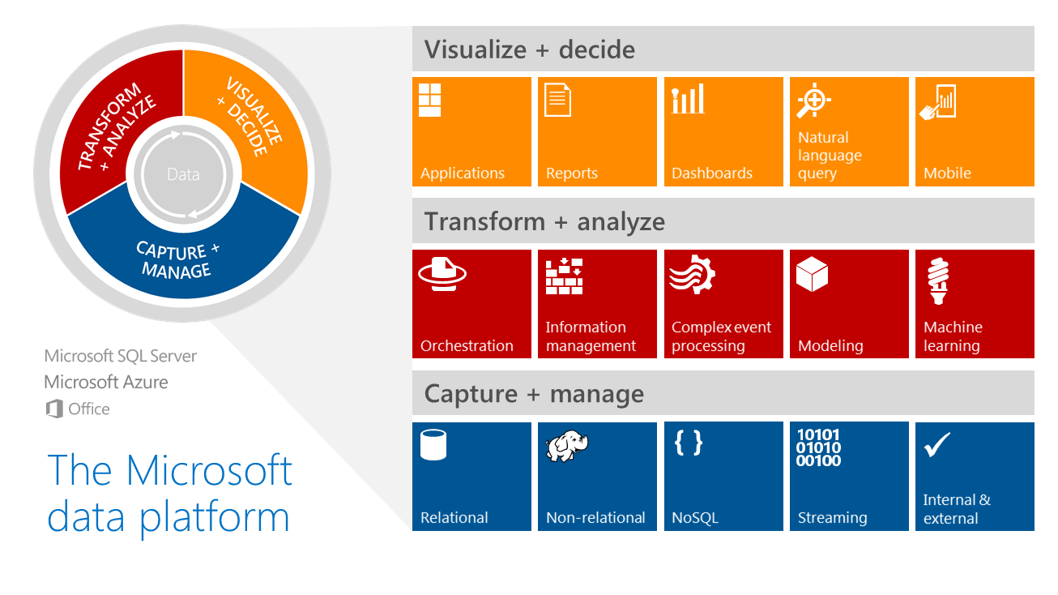

https://cloudblogs.microsoft.com/uploads/prod/2018/03/Microsoft20data20platform\_11042014.png

# Additional Datasets

## City of Toronto Building Permits

[https://www.toronto.ca/city-government/data-research-maps/open-data/open-data-catalogue/#c9117f72-4eaf-5e45-f3a6-b8b465074217](https://www.toronto.ca/city-government/data-research-maps/open-data/open-data-catalogue/" \l "c9117f72-4eaf-5e45-f3a6-b8b465074217" \t "_blank)

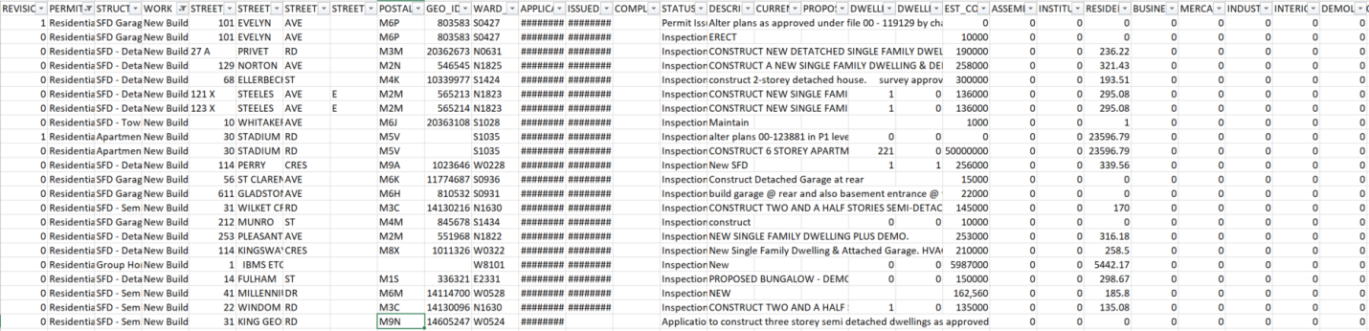

## Pizza restaurants and the pizzas they sell – Kaggle

[https://www.kaggle.com/datafiniti/pizza-restaurants-and-the-pizza-they-sell/version/1#8358\_1.csv](https://www.kaggle.com/datafiniti/pizza-restaurants-and-the-pizza-they-sell/version/1" \l "8358_1.csv)

<https://datafiniti.co/products/business-data/>

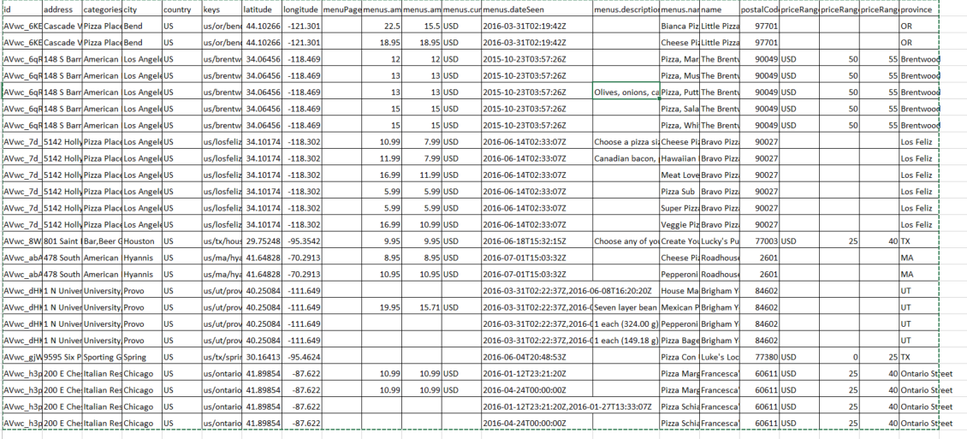

## Yelp Restaurant Review

https://twitter.com/search?vertical=default&q=pizza&src=typd

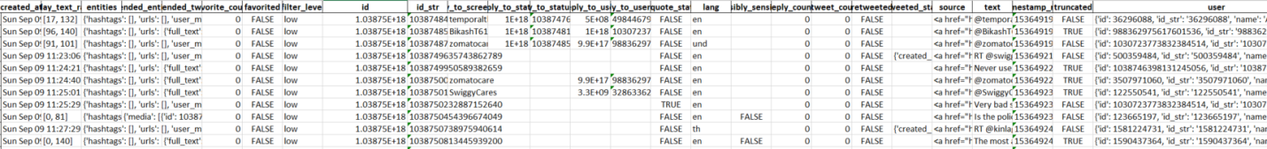

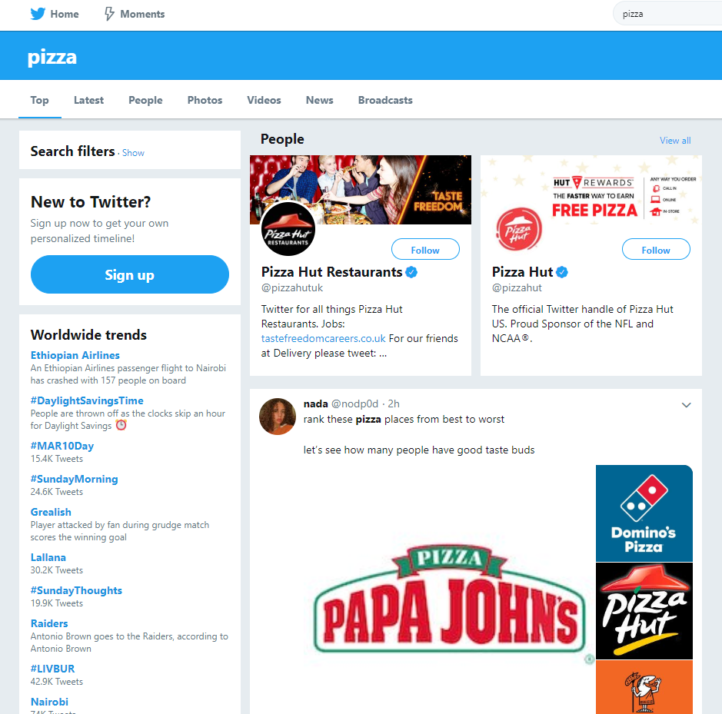

## Twitter Reviews - Online Food Ordering Services



## Air Miles Canada Loyalty data







## Toronto - 2016\_neighbourhood\_profiles – Statistics Canada



# Data set analysis



# Strategic Workloads



## Efficient Life Cycle of Food and Beverage Ingredients

The food industry is constantly growing to be able to accommodate the hectic life styles, but customers are still looking for authentic ingredients in their food. The best way for DVP to stay ahead of their competitors is by convert to organic locally grown ingredients, and manufactured foods and beverages. This will allow DVP to have a much more attractive menu while reducing food waste. The food life cycle management will fit perfectly with the new gourmet menu options in the upscale neighborhoods once everything is finalized. The goal is to keep customers satisfied while reducing operational cost. Before we set this new project in motion there are few things to considered

DVP have to stay on top of new trends to be able to boost their innovation process by doing so it will enable DVP to improve margins that will lead to healthier growth. Quick and accurate introductions of innovative products will give DVP a competitive advantage if they properly launch new menu selections and concept developments.

The food service industry is facing extreme regulatory compliance requirements at the moment: both locally and on a global scale. It is imperative for Da Vinci’s Pizza to incorporate safe food practices to comply with the constantly updating regulations.

To gain a competitive advantages, Da Vinci Pizza should implement a Food Service Platform to manage their products menus life cycle. A [Product Lifecycle Management solution for food service management](https://www.lascom.com/solutions/plm-software-food-service-and-catering/) is a powerful tool to help companies with daily challenges. **Below are some key functions that the software would have.**

**Food Service Software Key Functions**

* Supervise development of new recipes, ranges, menus
* Manage changes
* Calculate product prices considering supplier prices
* [Regulatory compliance](https://www.lascom.com/challenges/food-compliance/)
* Traceability
* Non-conformances and claims management
* Optimize collaboration
* Centralized data and documents about products and menus
* Management of [menu formulation](https://www.lascom.com/challenges/product-formulation-management/) and “in-store” labeling

**Benefits of Food Service Management**

|  |  |  |  |
| --- | --- | --- | --- |
| **Productivity Improvement** | **Quality Improvement** | **Strategy Improvement** | |
| - Avoiding information retrieval - Standardizing information - Internal and external exchange cycle reduced by 70% - Automatic generation of documentation product sheet, list of ingredients | - Manage the impacts of changes - Trace all exchanges - Simplify the management of health alerts on menus and products - Ensuring regulatory compliance - Time spent on checks quality reduced by 30% | | - Have an overview of development processes - Master the costs  - Monitor compliance with deadlines and tasks - Prioritize projects and manage the portfolio of existing products - Building a strategic business vision Time-to-market reduced by 30% |

**Food Service Management Software Success Stories**



## Franchising the business

Based on the 8 years financial results, the DaVinci’s Pizza is running well. In order to grow the business, we have developed a franchise model which will allow us to have someone else – the franchisee – open their restaurant in another area. As a result, the name, the food and the environment are the same, but the franchisee owns the business and pays a monthly royalty for use of our brand. As per our estimation, it will an easier and less expensive way to expand the pizza business.

Considering the risks associated with competitors edging over Da Vinci’s Pizza due to management’s limitations to curtail operational costs, it would be logical for Da Vinci’s Pizza to offer franchise to potential interested parties. This strategy would be similar to offering shares to stakeholders where for a dollar price associates are offered to buy them, and buyers get opportunity to ride on company’s success history.

Da Vinci’s Pizza success history of past eight years would offer a baseline to advertise and convince interested business entities to cash on already successful and widely known Pizza chain. Pizza chain franchises will have liberty to run operations with the only exception of yearly audit by parent company to validate similar operations and product quality across franchises. Franchises will pay royalty in return on annual basis.

Before we are executing the plan, some pros and cons need to be taken consideration:

**Pros**:

* With Franchisees, multiple pizza stores won’t need us to manage the day-to-day operations
* The franchisee takes on the bulk of the financial commitment.
* Less risk, as franchisees take on liability for what happens in their restaurants.
* Increase the brand recognition with more locations.

**Cons**:

* Less control.
* Initial expense might run upward of $100,000.
* More marketing responsibilities: increase in reach and marketing to get franchisees.

**Investment Tables for potential franchisees:**

|  |  |  |
| --- | --- | --- |
| **Name of Fee** | **Low** | **High** |
| **Initial Fee** | **$0** | **$10,000** |
| **Leasehold Improvements** | **$5,000** | **$225,000** |
| **Furniture, Fixtures and Equipment** | **$62,000** | **$145,000** |
| **Security Deposit** | **$1,000** | **$10,000** |
| **Opening Inventory and Supplies** | **$2,750** | **$6,500** |
| **Opening Advertising and Promotion** | **$0** | **$3,000** |
| **Training Expenses** | **$1,000** | **$3,000** |
| **Domino's PULSE Training Expenses** | **$1,500** | **$1,500** |
| **Insurance** | **$6,000** | **$17,000** |
| **Miscellaneous Opening Costs** | **$2,500** | **$7,000** |
| **Additional Funds - 3 Months** | **$10,000** | **$73,000** |
| **TOTAL ESTIMATED INITIAL INVESTMENT** | **$99,950** | **$561,000** |

## Identify new locations

We have set up the company with SAS in order to run ad-hoc analysis quickly and easily. Identifying new locations is not something that the company be doing daily or even weekly so we feel that setting up a database is not a good use of resources.

SAS allows the company to take various files and data from different sources and combine them to arrive at decisions of this type.

In this case we have taken data from the following public sources:

-Toronto.ca (neighbourhood profiles, permits database, public works)  
-Realtor.ca (house/business property prices)  
-Google Maps (identify locations of competition and like-minded businesses)  
-Yelp (analyze reviews on competition and client preferences)

We also leveraged the following internal data:

-Current customer delivery database  
-Financial information  
-Community data

After careful analysis we have come up with the following 10 primary targets for a new location:

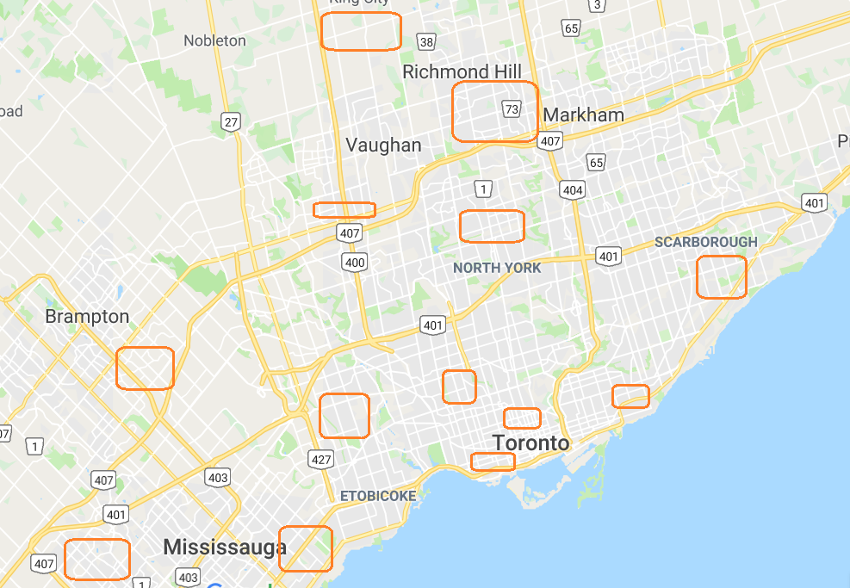

# Tactical Workloads



## Create a pizza community

In order to facilitate customer engagement with the app and therefore the store, the mobile app will have a “Community” section.

Through this feature customers are able to share their thoughts and ideas on how to balance their love of pizza with their healthy lifestyle.

The app allows the customer to import and invite contacts from other social media apps, create private and public groups to interact with one another and with the company.

The community has the ability for third party companies, such as nutrition experts and fitness-oriented companies to reach out to our customers, enabling us to capitalize on all the data captured by charging these third-party companies for the interaction with potential or current clients.

The company leverages this data for marketing, promotions, identifying new locations to open. The information gathered is large and it needs to be dynamic and real time. The key for this information is to understand the relationships and networks maintained between customers.

As such we set up a Neo4j database to handle the Community aspect of the app. This type of database will cover all of the needs mentioned above.

## AIR MILES Rewards Program

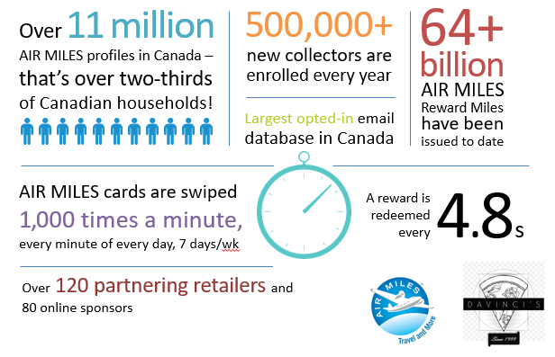

Based on Air Miles data, the performance of the Air Miles program at other partners has grown since late 2018. Most promotions are driving a return of 2x sales which is a margin positive.

Air Miles programs have higher active memberships than the average retail program due to:

* More opportunities to earn, across more categories of spend
* Appeal & flexibility of redemption options
* Credit card partnerships

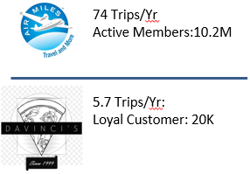As we franchise the business, customer engagement will become a challenge as Davinci’s Pizza only has fewer trips per year. With Air Miles on board, the program will help us to have a program that are:

* Easy to use (e.g. app, phone # as alternatives to physical card)
* Effectively leverage promotions to drive frequency
* Have achievable redemption thresholds

Also, based on the Air Miles data, membership, reach and engagement with the loyalty program are essential for driving sales with promotions.

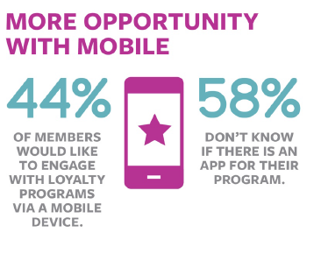With our Mobile App:

* Mobile apps are important for engagement and reach but need to be marketed to be successful
* Davinci’s Pizza is launching a new app and this project would need to align with loyalty if we decide to launch a program

## The AIR MILES Reward Program: Redemption, Earn Rate & Partners (Estimation)

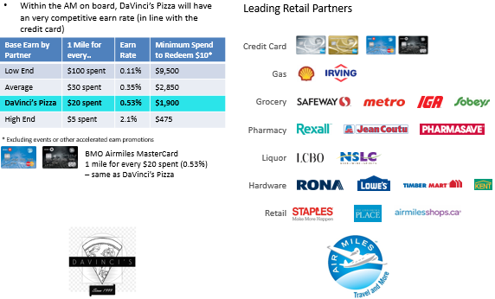

**Estimates Costs to Launch a Loyalty Program with Air Miles**

|  |  |  |  |  |  |  |
| --- | --- | --- | --- | --- | --- | --- |
|  | **Costs** | **Year 1** | **Year 2** | **Year 3** | **Year 4** | **Year 5** |
| **IT** |  |  |  |  |  |  |
| Web/Mobile App Design | $500,000 |  |  |  |  |  |
| Internal IT Costs | $750,000 |  |  |  |  |  |
| **IT CAPEX** | **$1,750,000** | **$0** | **$0** | **$0** | **$0** | **$0** |
| Ongoing Web/Mobile App Development |  | $50,000 | $50,000 | $50,000 | $50,000 | $50,000 |
| Management Vendor |  | $1,800,000 | $1,800,000 | $1,800,000 | $1,800,000 | $1,800,000 |
| Internal IT Costs |  | $100,000 | $100,000 | $100,000 | $100,000 | $100,000 |
| Fraud Monitoring |  | $100,000 | $100,000 | $100,000 | $100,000 | $100,000 |
| **IT OPEX** | **$0** | **$2,050,000** | **$2,050,000** | **$2,050,000** | **$2,050,000** | **$2,050,000** |
| **Restaurant Operational Costs** |  |  |  |  |  |  |
| POP/Merchandisers | $500,000 |  |  |  |  |  |
| Loyalty Cards | $360,000 | $432,000 | $432,000 | $432,000 | $432,000 | $432,000 |
| Training Materials | $100,000 |  |  |  |  |  |
| **Total Restaurant OPEX** | **$960,000** | **$432,000** | **$432,000** | **$432,000** | **$432,000** | **$432,000** |
| **Marketing Launch Costs** |  |  |  |  |  |  |
| Agency | $200,000 | $100,000 | $100,000 | $100,000 | $100,000 | $100,000 |
| TV/Radio production & Media | $2,000,000 |  |  |  |  |  |
| Digital/video Media | $250,000 |  |  |  |  |  |
| In-Store T-Shirts | $120,000 |  |  |  |  |  |
| Email Vendor |  | $50,000 | $50,000 | $50,000 | $50,000 | $50,000 |
| Digital Offer Targeting |  | $120,000 | $120,000 | $120,000 | $120,000 | $120,000 |
| Incremental Brand Marketing Media |  | $1,060,000 | $1,060,000 | $1,060,000 | $1,060,000 | $1,060,000 |
| **Total Marketing OPEX** | **$2,970,000** | **$1,330,000** | **$1,330,000** | **$1,330,000** | **$1,330,000** | **$1,330,000** |
| **Headcount** |  |  |  |  |  |  |
| Call Centre (2 ppl) |  | $120,000 | $120,000 | $120,000 | $120,000 | $120,000 |
| Loyalty Team (Director, 2 marketing, 2 analysts) |  | $540,000 | $540,000 | $540,000 | $540,000 | $540,000 |
| Finance (1 ppl) |  | $120,000 | $120,000 | $120,000 | $120,000 | $120,000 |
| IT (1 ppl) |  | $120,000 | $120,000 | $120,000 | $120,000 | $120,000 |
| **Total Headcount OPEX** | **$0** | **$900,000** | **$900,000** | **$900,000** | **$900,000** | **$900,000** |
| **Consulting/Other** |  |  |  |  |  |  |
| Professional services |  | $150,000 | $150,000 | $150,000 | $150,000 | $150,000 |
| **Total Consulting OPEX** | **$0** | **$150,000** | **$150,000** | **$150,000** | **$150,000** | **$150,000** |
| **Total CAPEX** | **$1,750,000** | **$0** | **$0** | **$0** | **$0** | **$0** |
| **Total OPEX** | **$3,930,000** | **$4,862,000** | **$4,862,000** | **$4,862,000** | **$4,862,000** | **$4,862,000** |

# Operational Workloads



## Internal KPI

Management dashboards will be included based on data from the internal corporate date. The chart on the follow page is a subset of the data from:

* Financial Information,
* Staff Performance
* menu items data
* customer delivery data

This data will be setup on an automated schedule depending on the data set. The example below will be delivered on a monthly basis. However, different datasets will be delivered on a monthly and daily view to identify and resolve key performance issues as they arise and before they become a larger issue. These can be adjusted on a quarterly basis as part of the ongoing consulting commitment.

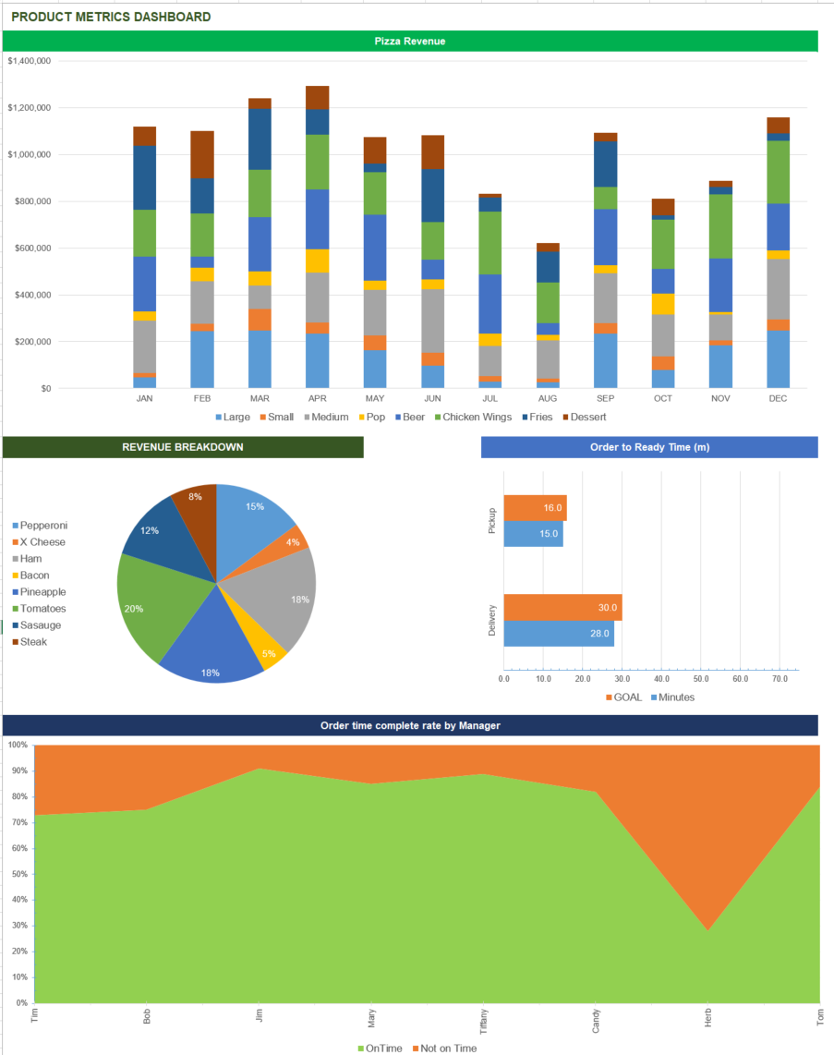

<https://www.smartsheet.com/free-excel-dashboard-templates>

## Online/mobile App Ordering and Delivery System

The demand for online ordering grows among food businesses, so is the need for DVP to find a solution that allows customers to browse their menus from anywhere. What better way to capture customers and potential customers than right where they are which is usually on their mobile devices. A mobile app will provide customers instant access to your menus and be able to make different menu options and selections. Customers will have to option to pick-up or deliveries with various payment options. The mobile app will have tracking system to manage orders and track deliveries. With the launch of a mobile app we need to make sure that the models are built to perfection. Everything needs to function perfectly to ensure that we answer every possible question. With the launch of the mobile app DVP will be creating a branded ordering experience for each customer

**Model Considerations for delivery orders**

* Who ordered the meal
* Is the order to be picked up at the restaurant
* Where and when the meal should be delivered
* What meals, sides and drinks are included in the order
* What ingredients is needed to fulfill the order
* If the order has already been paid for

**Delivery Orders Model Visual**

A sample data model Da Vinci’s Pizza illustrating how to organize, manage, and store the restaurant’s delivery orders is shown below. This objective is to allow Da Vinci’s Pizza to track the status of each order while capturing the financial details.

**Customers Model**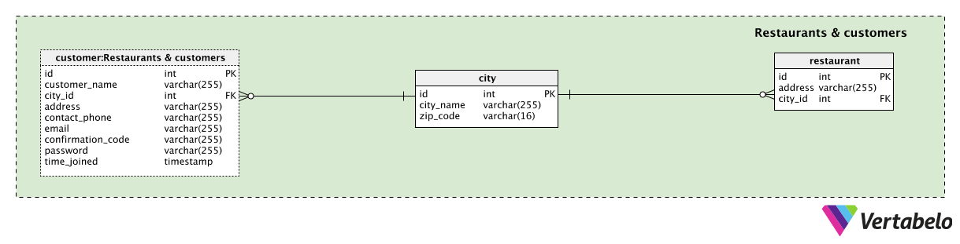

**Menu Model**

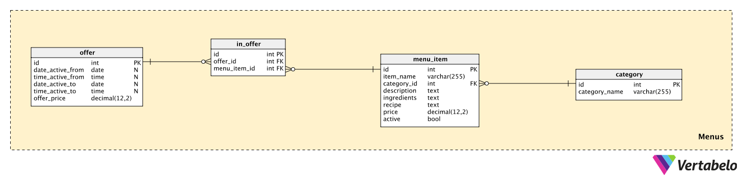

**Orders Model**

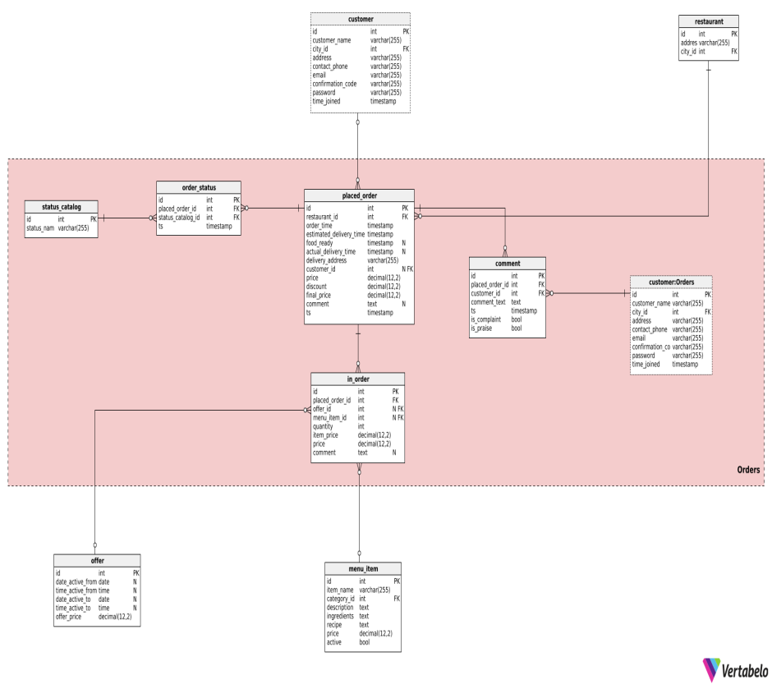

Estimated cost to launch a basic mobile app

|  |  |  |  |  |  |  |
| --- | --- | --- | --- | --- | --- | --- |
| Ball-park Cost Breakdown for **Native App Development: Android & iPhone** | | | | | | |
| Project | Small MVP | Small Enterprise | Medium MVP | Medium Enterprise | Large MVP | Large Enterprise |
| Discovery and Wireframing | $1,500 | $2,500 | $2,500 | $3,500 | $5,000 | $9,000 |
| App Screen Designs | $2,000 | $3,000 | $3,500 | $5,000 | $5,000 | $9,000 |
| iOS native development | $9,000 | $11,000 | $37,000 | $45,000 | $60,000 | $90,000 |
| Android native development | $9,000 | $11,000 | $37,000 | $45,000 | $60,000 | $90,000 |
| Back-end Programing, Database and APIs | $5,000 | $7,000 | $9,000 | $10,000 | $12,000 | $12,000 |
| Application Administration | N/A | $7,500 | $9,000 | $15,000 | $10,000 | $20,000 |
| Quality Assurance and Refinements iOS | $2,000 | $2,500 | $5,000 | $6,500 | $7,000 | $9,000 |
| Quality Assurance and Refinements Android | $2,000 | $2,500 | $5,000 | $6,500 | $7,000 | $9,000 |
| Deployment and Cloud | $1,500 | $2,000 | $2,000 | $3,000 | $2,000 | $3,000 |
| **Total (One Platform)** | $21,000 | $35,500 | $68,000 | $81,000 | $101,000 | $152,000 |
| **Total (Android and iPhone)** | $32,000 | $49,000 | $110,000 | $125,500 | $168,000 | $251,000 |

**Costs Breakdown for a hybrid app development**

|  |  |  |  |  |  |  |
| --- | --- | --- | --- | --- | --- | --- |
| Ball-park Cost Breakdown for **Hybrid App Development: Android & iPhone** | | | | | | |
| Project | Small MVP | Small Enterprise | Medium MVP | Medium Enterprise | Large MVP | Large Enterprise |
| Discovery and Wireframing | $1,500 | $2,500 | $2,500 | $3,500 | $5,000 | $7,500 |
| App Screen Designs | $2,000 | $3,000 | $3,500 | $6,000 | $5,000 | $9,000 |
| Hybrid App Development using PhoneGap technology | $10,000 | $12,000 | $38,000 | $45,000 | $65,000 | $100,000 |
| Back-end Programing, Database and APIs | $5,000 | $7,000 | $9,000 | $10,000 | $12,000 | $12,000 |
| Application Administration | N/A | $7,500 | $9,000 | $15,000 | $10,000 | $20,000 |
| Quality Assurance and Refinements | $2,000 | $4,000 | $5,000 | $7,000 | $9,000 | $11,000 |
| Deployment and Cloud | $1,500 | $2,500 | $2,000 | $3,000 | $2,000 | $3,000 |
| Total (Android & iPhone) | $22,000 | $38,500 | $69,000 | $89,500 | $108,000 | $162,500 |

# Summary

SM2R2 Consulting Group has identified several analytic opportunities for Da Vinci’s Pizza to grow using both internal and external data sources. The Microsoft Azure platform is a stable and secure platform to scale the data as needed. Our solution will assist with cost optimization, regulatory compliance and improve the overall customer experience. This strategy will help facilitate DaVinci’s strategic growth initiative.

# Peer Review

|  |  |
| --- | --- |
| **Susiette** | Provided an equal contribution |
| **Savitha** | Provided an equal contribution |
| **Ron** | Provided an equal contribution |
| **Michael** | Provided an equal contribution |
| **Marco** | Provided an equal contribution |
| **Ray** | Provided an equal contribution |